checkpoint：应用定时触发，用户保存状态，会过期，内部应用失败重启的时候使用，默认情况下cancel时，会删除之前的checkpoint。

savepoint：用户手动执行，不会过期，相当于备份，可以在cancel的时候使用。一般可以用于修改并行度，程序升级等等。

所以如果想要在程序停掉后重启，数据一致的情况下，强烈推荐使用cancel时做savepoint，当然，如果程序中没有涉及到state，可以不用。

1.1 配置文件修改

在flink-conf.yaml中配置savepoint存储位置，不是必须设置，如果设置了，那么做savepoint的时候，可以不指定位置，系统会默认使用你设置的位置。如果没有设置，那么在做savepoint的时候，必须指定位置，不然就会报错。

[hadoop@h201 ~]$ vi flink-1.7.2/conf/flink-conf.yaml

state.savepoints.dir: hdfs://192.168.8.201:9000/flink-checkpoints

1.2 启动hadoop 和flink

1.3 启动 flink任务

开发：

**package** com.state;  
  
**import** org.apache.flink.api.common.functions.MapFunction;  
**import** org.apache.flink.api.common.functions.RichFlatMapFunction;  
**import** org.apache.flink.api.common.state.ValueState;  
**import** org.apache.flink.api.common.state.ValueStateDescriptor;  
**import** org.apache.flink.api.common.typeinfo.TypeHint;  
**import** org.apache.flink.api.common.typeinfo.TypeInformation;  
**import** org.apache.flink.api.java.tuple.Tuple2;  
**import** org.apache.flink.configuration.Configuration;  
**import** org.apache.flink.streaming.api.CheckpointingMode;  
**import** org.apache.flink.streaming.api.datastream.DataStream;  
**import** org.apache.flink.streaming.api.environment.StreamExecutionEnvironment;  
**import** org.apache.flink.streaming.api.windowing.time.Time;  
**import** org.apache.flink.util.Collector;  
  
  
  
**public class** s5 {  
 **public static void** main(String[] args) **throws** Exception {  
 StreamExecutionEnvironment env = StreamExecutionEnvironment.*getExecutionEnvironment*();  
 env.enableCheckpointing(1000);  
 env.getCheckpointConfig().setCheckpointingMode(CheckpointingMode.***EXACTLY_ONCE***);  
 env.getCheckpointConfig().setCheckpointTimeout(60000);  
 env.getCheckpointConfig().setMinPauseBetweenCheckpoints(500);  
 env.getCheckpointConfig().setMaxConcurrentCheckpoints(2);  
 env.getCheckpointConfig().setFailOnCheckpointingErrors(**false**);  
 DataStream<Tuple2<Long,Long>> a1 = env.socketTextStream(**"192.168.8.201"**, 9999).map(**new** MapFunction<String, Tuple2<Long,Long>>() {  
 @Override  
 **public** Tuple2<Long,Long> map(String s) **throws** Exception {  
 **return new** Tuple2<Long,Long>(Long.*parseLong*(s.split(**" "**)[0]),Long.*parseLong*(s.split(**" "**)[1]));  
 }  
 });  
  
 a1.keyBy(0).flatMap(**new** CountWindowAverage()).print();  
 env.execute(**"s5"**);  
  
 }  
  
 **public static class** CountWindowAverage **extends** RichFlatMapFunction<Tuple2<Long, Long>, Tuple2<Long, Long>> {  
 **private transient** ValueState<Tuple2<Long, Long>> **sum**;  
  
 @Override  
 **public void** flatMap(Tuple2<Long, Long> input, Collector<Tuple2<Long, Long>> out) **throws** Exception {  
  
 *// access the state value* Tuple2<Long, Long> currentSum = **sum**.value();  
  
 *// update the count* currentSum.**f0** += 1;  
  
 *// add the second field of the input value* currentSum.**f1** += input.**f1**;  
  
 *// update the state* **sum**.update(currentSum);  
  
 *// if the count reaches 2, emit the average and clear the state* **if** (currentSum.**f0** >= 2) {  
 out.collect(**new** Tuple2<>(input.**f0**, currentSum.**f1** / currentSum.**f0**));  
 }  
 }  
  
 @Override  
 **public void** open(Configuration config) {  
 ValueStateDescriptor<Tuple2<Long, Long>> descriptor =  
 **new** ValueStateDescriptor<>(  
 **"average"**, *// the state name* TypeInformation.*of*(**new** TypeHint<Tuple2<Long, Long>>() {}), *// type information* Tuple2.*of*(0L, 0L)); *// default value of the state, if nothing was set* **sum** = getRuntimeContext().getState(descriptor);  
 }  
 }  
}

1.4 查看jobid

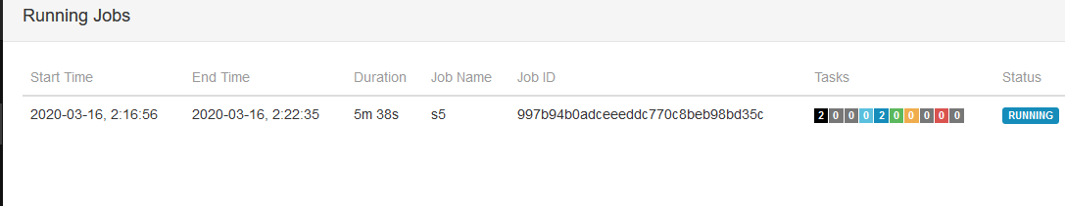

1.5 启动savepoint

[hadoop@h201 flink-1.7.2]$ bin/flink savepoint 997b94b0adceeeddc770c8beb98bd35c

1.6 恢复

[hadoop@h201 flink-1.7.2]$ bin/flink run -s hdfs://h201:9000/flink-checkpoints/savepoint-c24586-97d3805650cb /home/hadoop/qq/q3flink12.jar